**COVID-19 Effects on Public School Education Performance**

Group 9: Adam Micek, Anjana Azhuvath, Joel Bradshaw, Kenny Evans, Stef Cazares

ECMT 673 Term Project

Dr. Craig Schulman

November 28, 2023

**Index**

**Introduction 3**

**Literature Review 5**

**Data 8**

**Findings 9**

**Conclusion 19**

**Works Cited 22**

## Introduction

The beginning of COVID-19 was nearly four years ago, and yet its effects are still present to this day. COVID-19 impacted the United States in a multitude of ways. It led to a period of financial instability in the economy, affected the general public’s mental health, and overall changed our day-to-day lives with the precautionary methods that were put in place like social distancing. Additionally, changes were made to large sectors of the United States economy like public healthcare, the food industry, transportation, and education. In this paper, we will be focusing on how COVID-19 impacted education in Texas. Specifically, we will be looking at STAAR test scores across schools in Texas and seeing what changed before and after the pandemic.

STAAR or The State of Texas Assessments of Academic Readiness is a standardized test used by the Texas Education Agency in order to determine whether students are qualified to move onto the next grade level. The STAAR tests cover core subjects such as reading, science, social studies, and math. The test material is modeled off of the state curriculum standards. Students from grades 3-12 attending a public school in Texas are required by law to take the STAAR test. A student's performance is placed into one of four categories: “Did Not Meet Grade Level”, “Approaches Grade Level”, “Meets Grade Level”, and “Masters Grade Level”. If a student receives a performance level of “Did Not Meet Grade Level”, then the student did not pass the test. However, receiving any of the other three categories means that the student has passed and will be allowed to move to the next grade level.

In the midst of COVID-19, changes to the education system had to be made in order to abide by social distancing laws. Because there could no longer be large groups of people in classrooms, much less a whole school, schools in Texas had to make quick adjustments and move learning from in-person to online in 2020. Many teachers only had experience teaching in-person classes so transitioning to online education in only a handful of weeks came with many adjustment issues. Teachers had to rapidly learn how to work new softwares like Zoom, Google Classroom, and Canvas, all whilst trying to also deal with the pandemic. But some issues also arose from the student’s side. There was a lack of motivation for students due to their surrounding circumstances, as well as the fact that they were not in a real classroom setting. It is easier for a student to get distracted when there is not a teacher present in the room telling them to stay on task. Additionally, for students who did not have access to a stable internet connection or electronic devices, it was almost impossible for them to receive the same level of education as their peers who had both of these things. A disparity or difference between ethnic groups and their access to technology is known as the digital divide. Statistics from the Pew Research Center show that Black and Hispanics are less likely to own computers or have high-speed internet when compared to White people. The COVID-19 caused large disruptions to the education system that people were forced to rapidly adjust to. Since 2020 was such a big adjustment period for teachers, students, and parents, Texas Governor, Greg Abbot, decided to waive the STAAR test requirements for the school year 2019-2020.

## Literature Review

The recent pandemic caused significant upheaval in classrooms and educational institutions throughout the United States. Studies unanimously suggest an unusual shift or divergence in the path of education during and after the pandemic years. Bozkurt et al. (2022) identified three main disruptions resulting from the pandemic: an educational crisis, mental health challenges, and the surge in online/hybrid learning. These disruptions have led to lower-than-usual state testing scores. It's not just how these disruptions affected the scores, but rather their occurrence itself. The lack of preparedness led to a halt in teaching as both students and teachers adjusted to this new reality. The absence of social interaction, feelings of isolation, and increased anxiety affected students everywhere. Additionally, hybrid learning and reduced accountability amplified the disruption beyond initial expectations. Bozkurt et al. (2022) explored these aspects to argue that the lack of continuity and educational enrichment during and after the pandemic might have contributed to below-average state test scores.

Experts had foreseen a substantial decline in academic learning and testing nationwide among students in the United States. Recent research by Burkholder and Salehi (2023) validated this prediction. However, their findings also highlighted that "first-generation students in STEM suffered more from the alterations in secondary instruction" compared to their peers. These outcomes suggest that minorities were disproportionately affected compared to their Caucasian counterparts. Foreign-born individuals enrolled in full-time education experienced a significant decline in performance, though the study doesn't explain why, merely noting the occurrence. Consequently, it's plausible to suggest that the pandemic had a more pronounced impact on minorities than on Caucasian individuals. These observations imply an unequal influence on learning outcomes based on ethnicity due to the pandemic.

Kuhfeld et al. (2022) delved deeper into this notion through a study examining the specific impact of these score declines on students in grades 3-8. They found that math scores in 2021 were 0.2 to 0.27 standard deviations lower than those in 2019. This research revealed that the pandemic had a lasting effect on younger students as well. Typically, younger students have less adaptability to hybrid learning environments as they absorb crucial information during their foundational years. Their need for a more structured day and learning setting meant that these grade levels were more adversely affected compared to, for instance, college or high school students. Although the study emphasizes that the students who experienced schooling during the pandemic aren't classified as a lost generation, they are expected to grapple with the repercussions for years to come.

At the onset of the COVID-19 pandemic, it was quite clear that children from more financially-troubled families would suffer a greater academic loss than those from higher-achieving families. Bailey et al. (2021) published a study that compared the achievement gap as forecasted by analysts to the real-world achievement gap seen following the pandemic-affected school year of 2020-2021. After studying forecasts of the achievement gap from prior to the school year, the authors used their own survey targeted towards education researchers to gather data on the true achievement gap expected from the pandemic. Between the evidence from the studied forecasts and the survey of education researchers, children from low-income families were anticipated to fall an additional half-year of learning behind their high-income family counterparts, a level that, if not counteracted in the near future, could seriously hurt these children who already come from backgrounds with lesser opportunities.

Students on average fell five months behind grade level expectations in math and four months behind in reading, while black and hispanic students saw even greater academic deficits, according to Dorn et al. (2021). Furthermore, their study found that dropout rates, absenteeism, and mental health cases all soared during the pandemic year while the number of students planning to pursue higher education declined significantly. Di Pietro (2023) used data from recent meta-analyses to find the average student’s academic loss from the pandemic year was about 0.19 standard deviations, a number quite comparable to the deficit suffered by students affected by Hurricane Katrina, as determined by Sacerdote (2012). Of course, some students lost less than others academically from the pandemic, but over a full year removed from the pandemic, Di Pietro (2023) found that the average student still had not recovered from their loss of learning.

## 

## Data

Using school-level information as our unit of observation, we gathered data from almost 9,000 different schools ranging from 1,207 school districts. We elected to omit some of these schools from our dataset based on missing records, incongruencies between data, or abnormal values. For the remaining schools we decided to split up our state exam scores by ethnicity. We decided to omit smaller ethnicity groups as the data was not significant in our overall model. From this, we only kept the four most ethnic groups: hispanic students, white students, black students, and asian students. Below are stacked bar graphs created separated by overall scores between each ethnicity.

*Overall Scores:*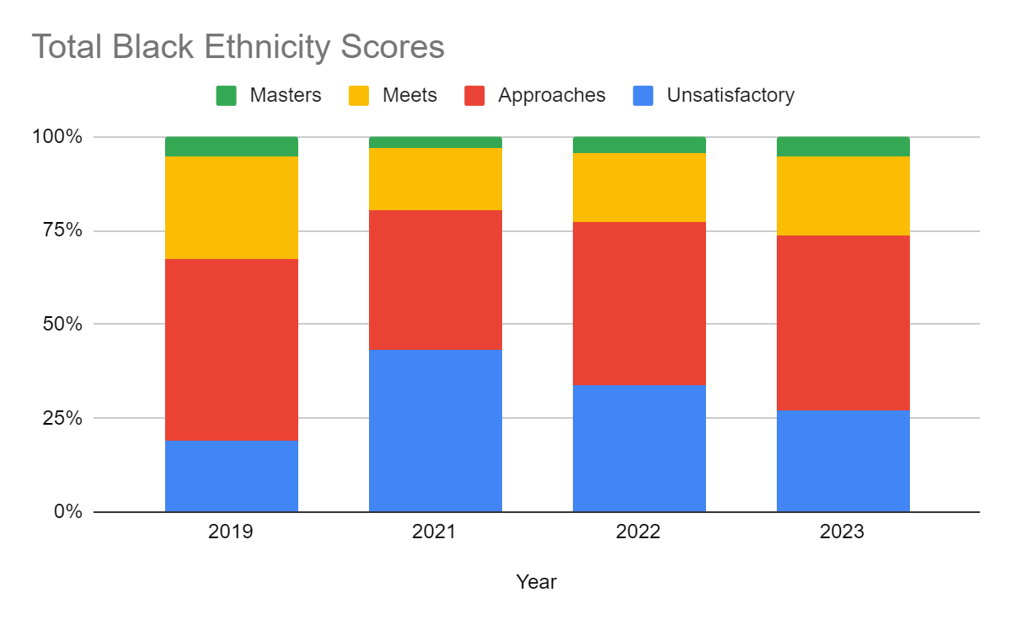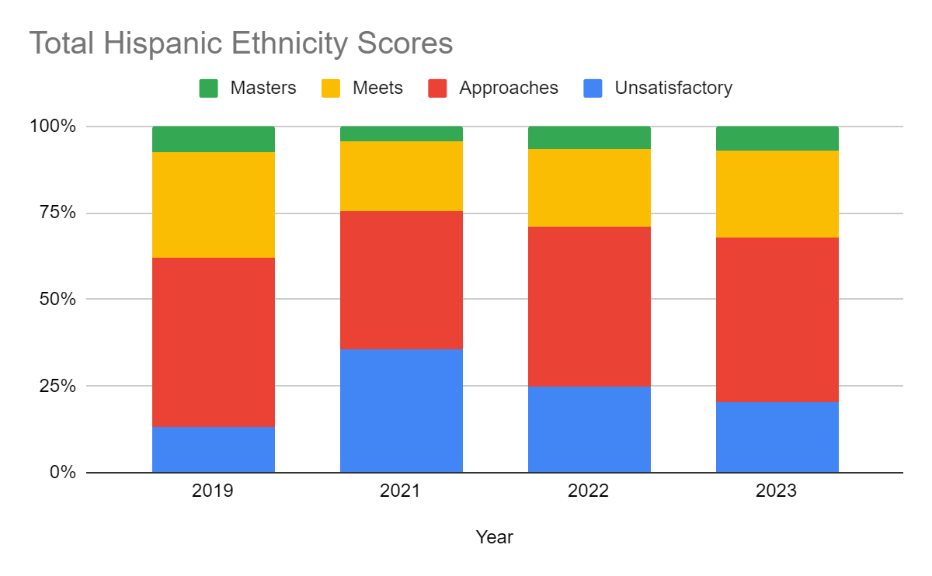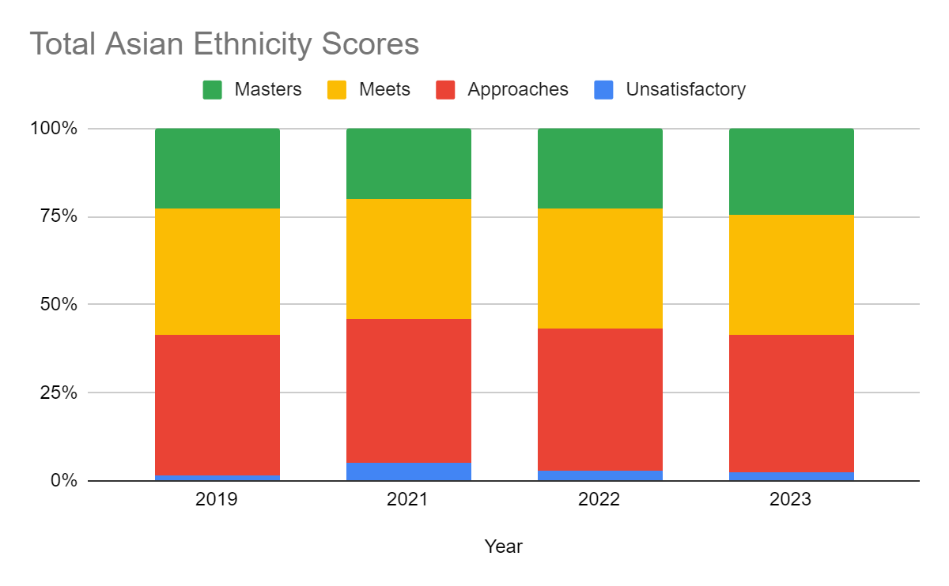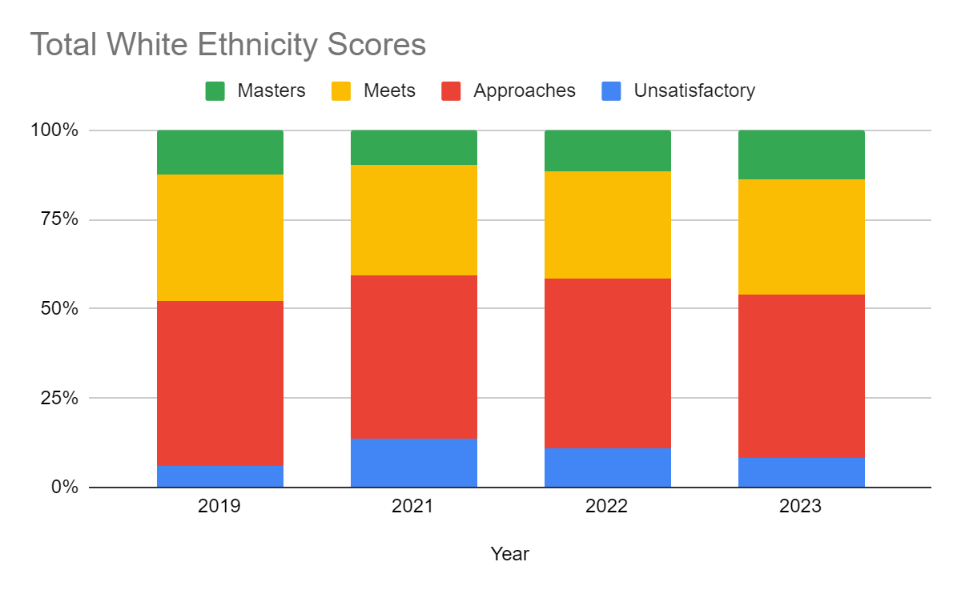

From the figure above, we can see that with the exception of Asian students, all of the three other major ethnicities have more than 50% of students that are unsatisfactory or approach the passing exam score. We can also see from the figures above, no matter the ethnicity, all scores seemed to spike in the 2020-2021 school year as this was the first time exams were taken after the pandemic.

For all the racial groups included in the charts above, the percentage of students that performed unsatisfactorily on the STARR exam spiked between 2019 and 2021, which makes sense given the early end to the 2019-2020 school year and the full pandemic year during the 2020-2021 school year impacting student learning. Fortunately, the above chart also shows that each year following 2021, the percentage of unsatisfactory scores decreases for each race, suggesting that students are beginning to recover from the learning loss of the pandemic.

## Findings

Based on the overall data found above, we then concluded that to best see which subgroup had been affected the most by the pandemic was to split up each ethnicity and compare how they did on the STAAR exam based on the individual subject tested on. Seeing how well students performed in each subject is also important in determining whether or not schools should provide better resources or educational opportunities to students in certain subjects over others. This could help students achieve higher grades on the STAAR exam, which as result helps the school and district.

*Reading Scores by Ethnicity:*

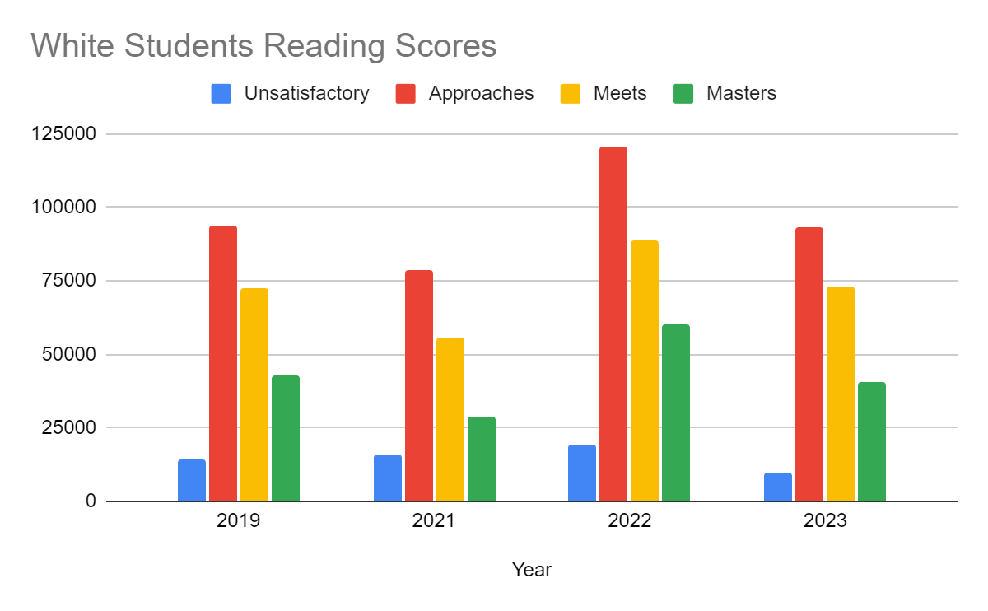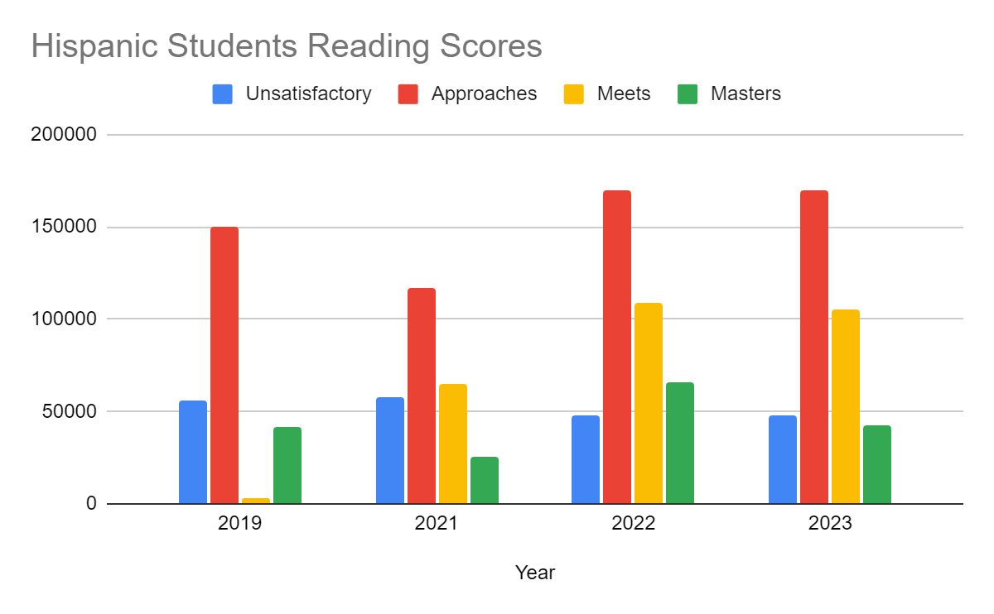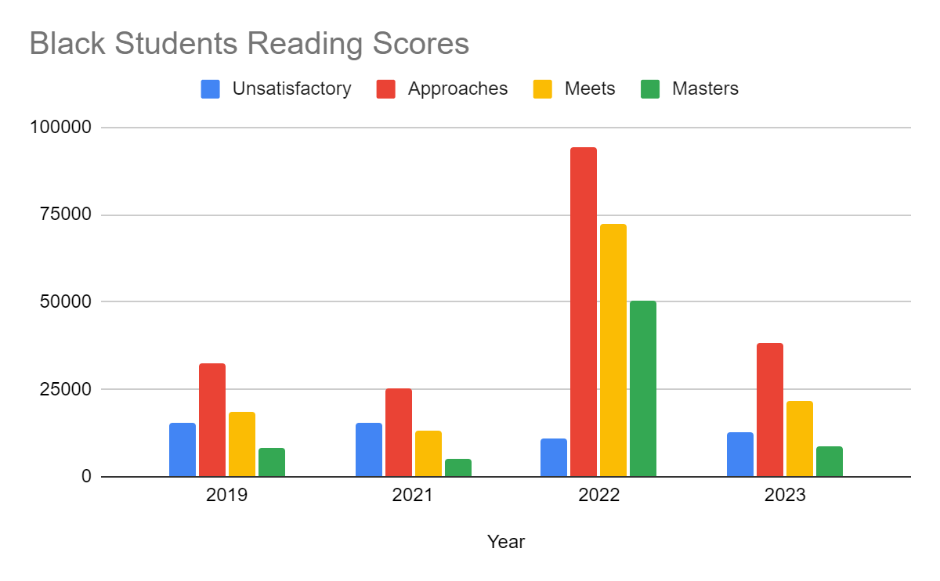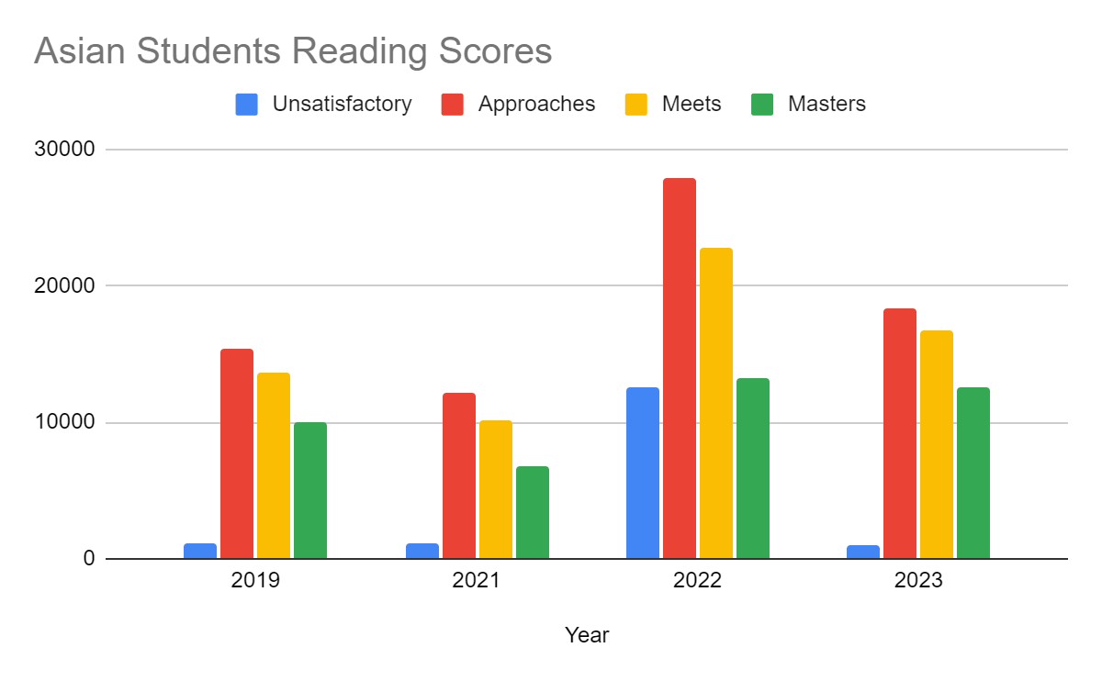

Based on the figures above, we can conclude that in the reading subject we see that with all ethnicities there seems to be a spike with students that “approach” exam scores in 2021-2022 school year. From the above graphs it can be seen that the students with the most “unsatisfactory” scores each year are from the hispanic population, with a high of 57,682 students failing the STAAR exam in 2020-2021 school year.

We notice that among all racial groups, fewer students took the STAAR reading test in 2021 than in any other year, which could potentially be attributed to a decrease in the number of students physically in school during the 2020-2021 school year. Additionally, while all racial groups seemed to have increased participation in testing in 2022, we noticed a particularly substantial spike in the number of black students who took the STAAR reading test that year. We are unsure if this sudden increase is coincidental, a sign of much higher attendance rates among black students in 2022, or simply a miscalculation.

*Science Scores by Ethnicity:*

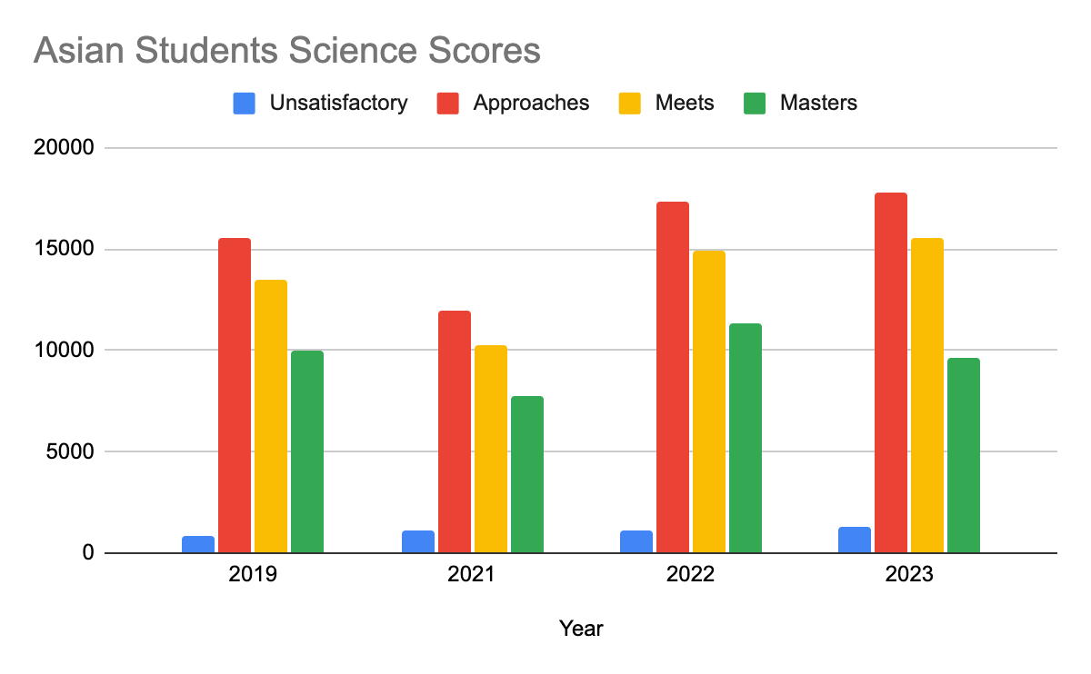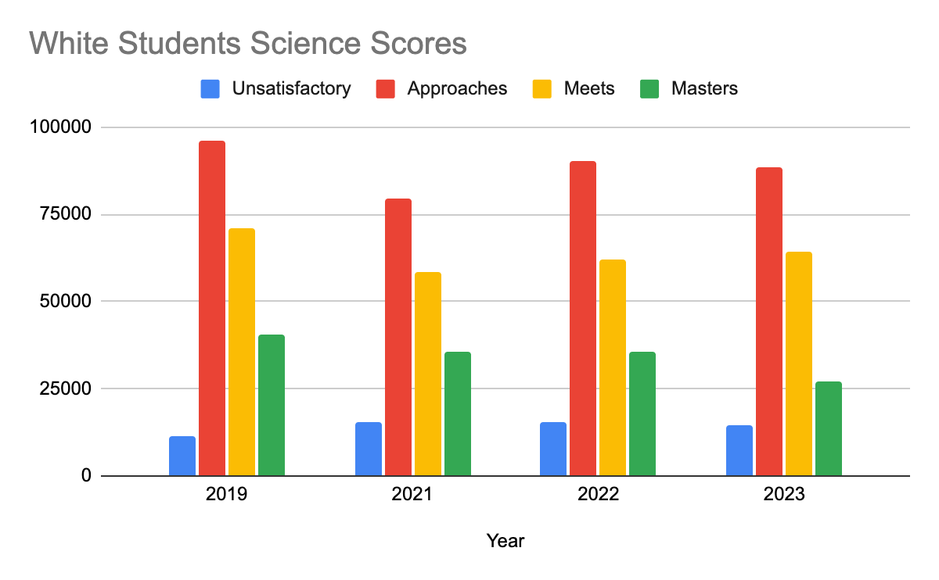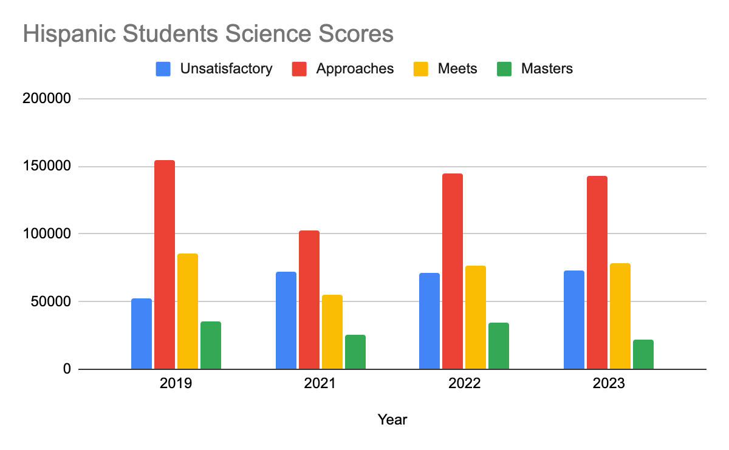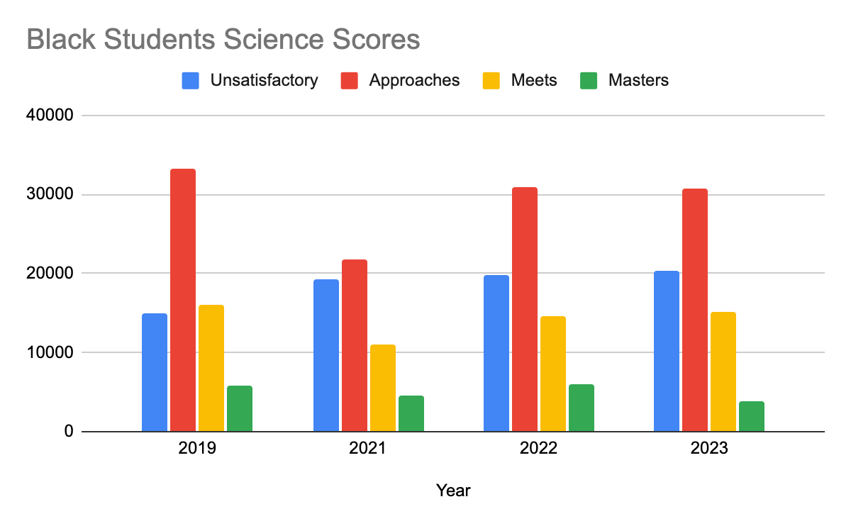

From the graphs above, we can see that under the science subject, the Hispanic student subgroup had the largest number of students performing “Unsatisfactory”. Additionally, all ethnic subgroups experienced an increase in “Unsatisfactory” performance, with the Asian subgroup showing the least amount of change in this performance category. Specifically, there was a 12.3% increase in “Unsatisfactory” Hispanic students, 3% increase in White Students, 12.7% increase in Black students, and 1.6% increase in Asian students from 2019 to 2021. Immediately following the COVID-19 pandemic, there was an overall decrease in the amount of students performing at a “Mastery” level for the 2020-2021 science STAAR test. Students have not been able to meet their “Mastery” level numbers from before the pandemic, with Asian students in 2022 being an exception.

*Social Studies Scores by Ethnicity:*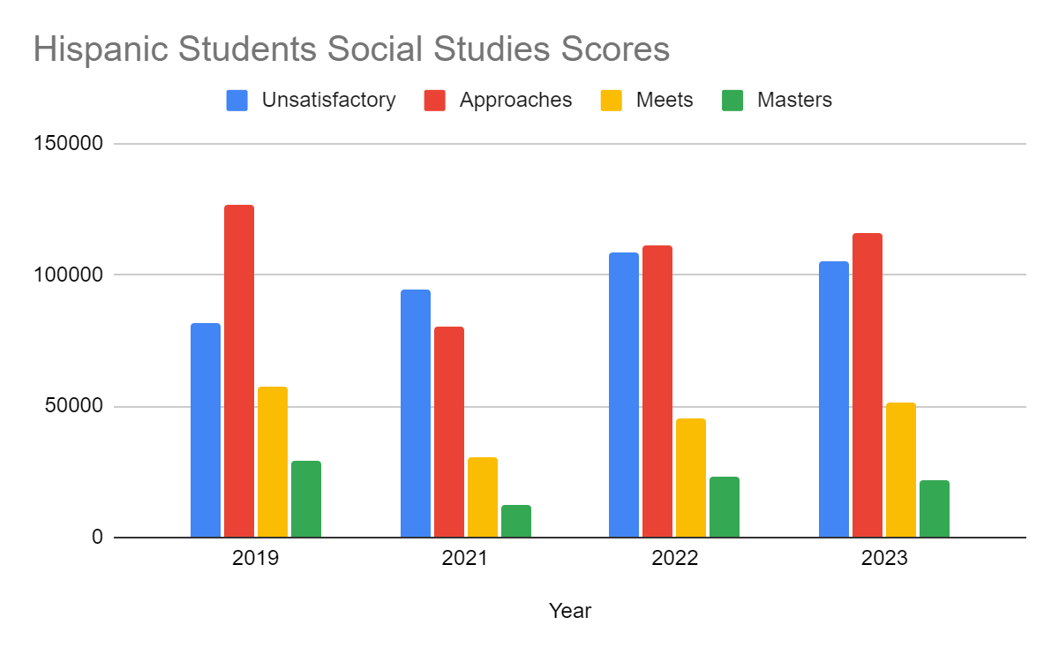

About 42% of the test takers in social science belonged to the Hispanic social group. Before the pandemic, 37.06% of Hispanic students scored unsatisfactory performance in social science, with only 9.94% of the 296,855 students mastering the material taught in social studies. The years 2021, 2022, and 2023 indicate a decline in learning outcomes related to the social sciences. Despite improvements, the data suggests that students were unable to meet or surpass pre-pandemic levels.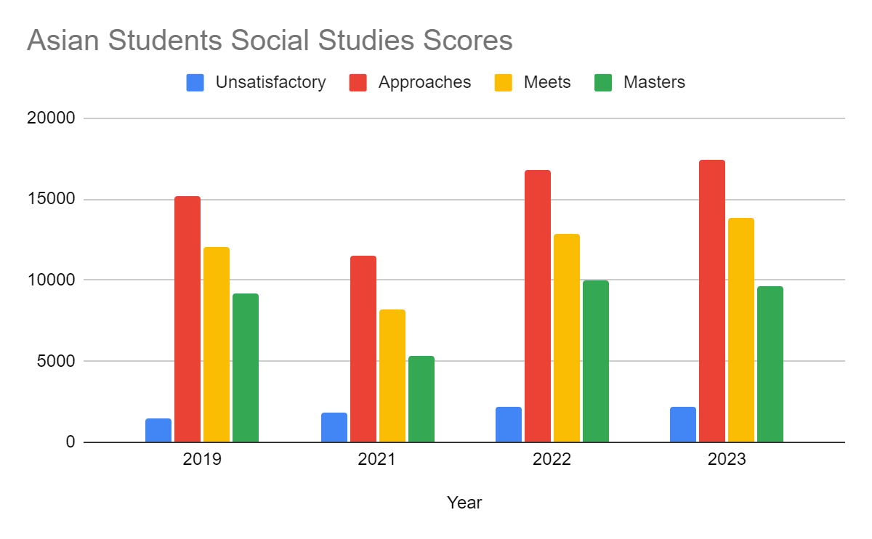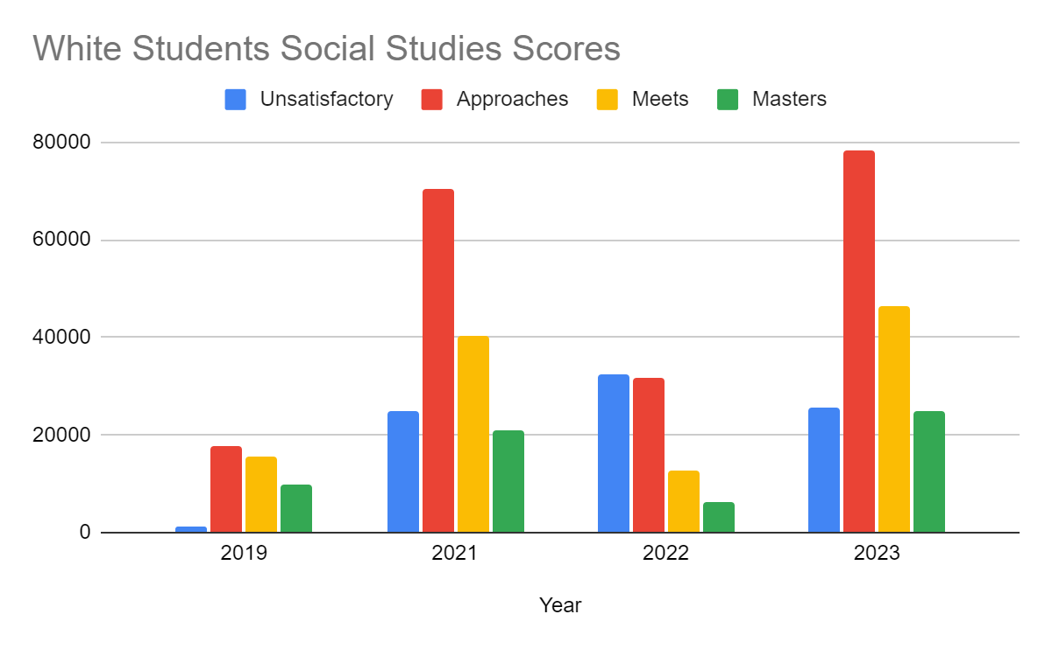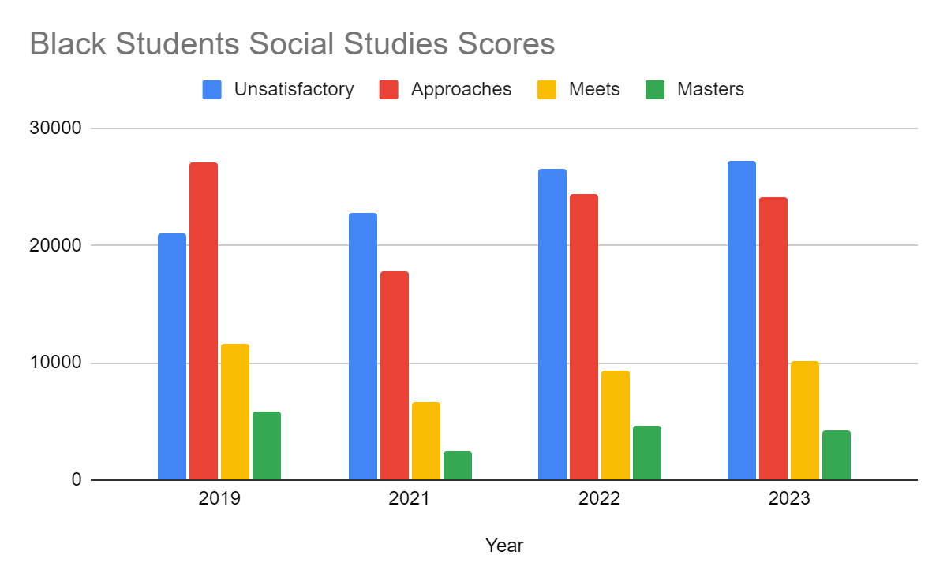

The decline in academic achievement is also evident among black students. In 2019, around 10% of the total students belonged to the black racial group. Of these students, 34.14% performed unsatisfactorily, not meeting grade level requirements. 40.04% approached the requirements in social studies. Immediately after the pandemic in 2019, there were significant losses in learning, with the total number of black cohorts taking the test falling to 7%. Among the 51,793 black students, the percentage with unsatisfactory grades increased to 44.09%. Only 4.91% of black test takers in social science mastered the subject compared to 8.65% prior to the pandemic. The percentage of students meeting grade level requirements consistently declined post-pandemic.

In 2019, the number of Asian students mastering the subject was as high as the white student population, around 9,000 students. Thirty-seven point ninety-six percent (37.96%) and 30.27% of Asian-origin students approached or met grade level requirements in 2019. Asian test takers were the only minority group to recover from the learning loss in social science caused by the pandemic. By 2023, the number of students approaching, meeting, and mastering grade level requirements in social studies surpassed pre-pandemic levels.

A comparison of pre- and post-pandemic performance of the white student population indicated mixed results. After 2019, the number of students with unsatisfactory performance in social studies increased by 95.02% from 1,273 (pre-pandemic levels). However, the percentage of students meeting or approaching grade level requirements improved over time. Similar to the Asian student population, they were able to exceed pre-pandemic levels.

*Math Scores by Ethnicity:*

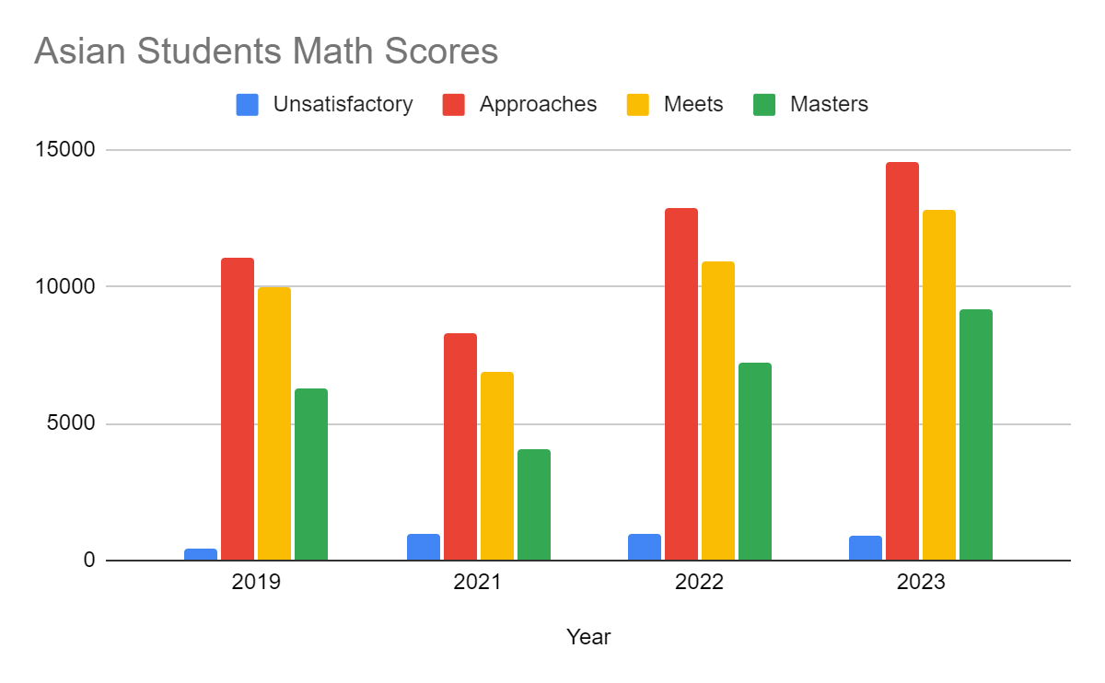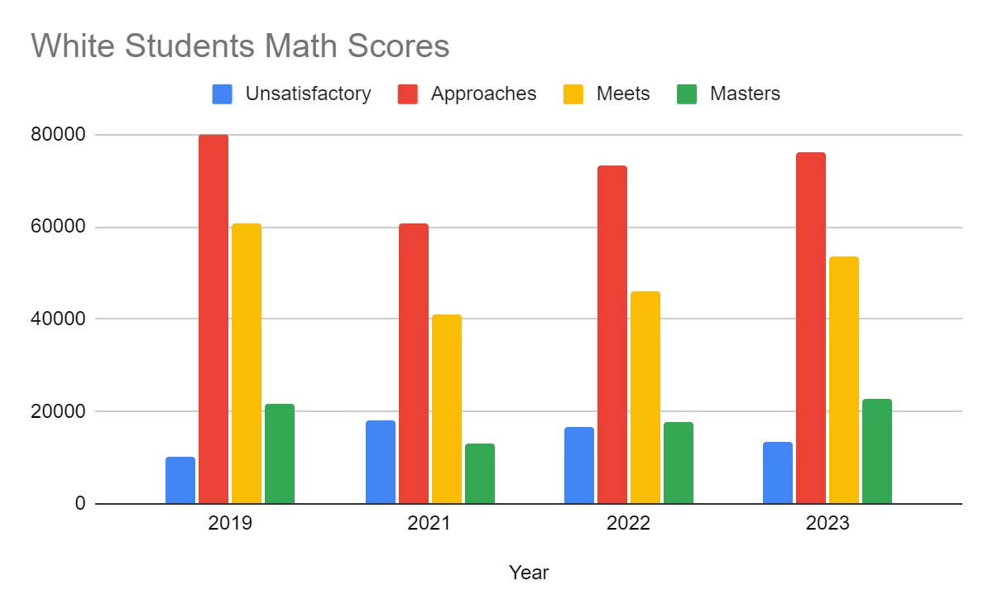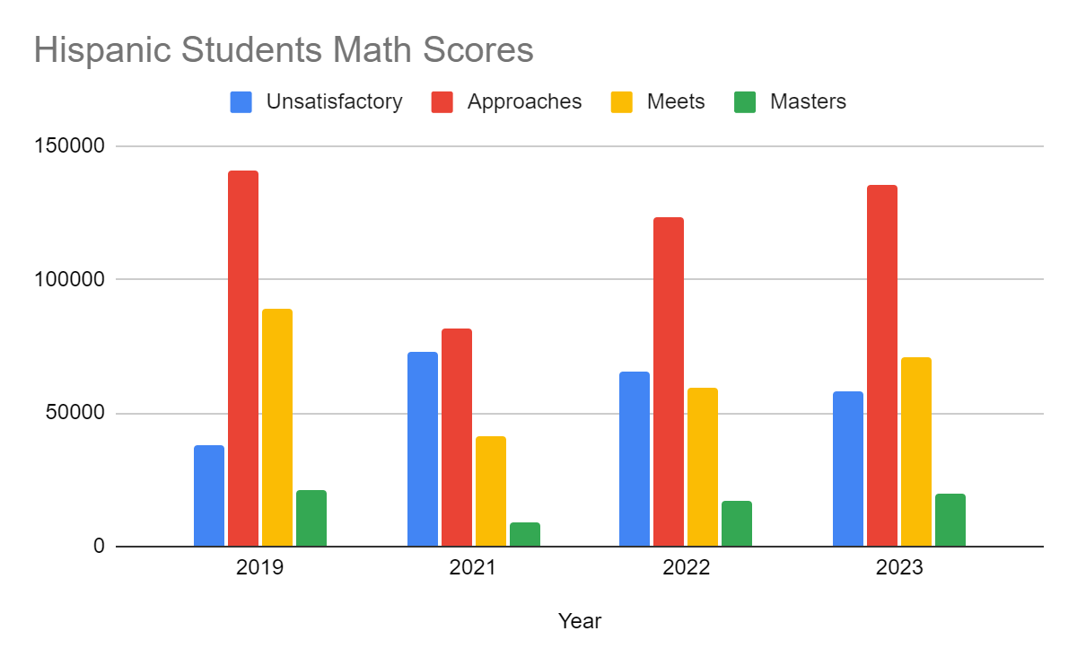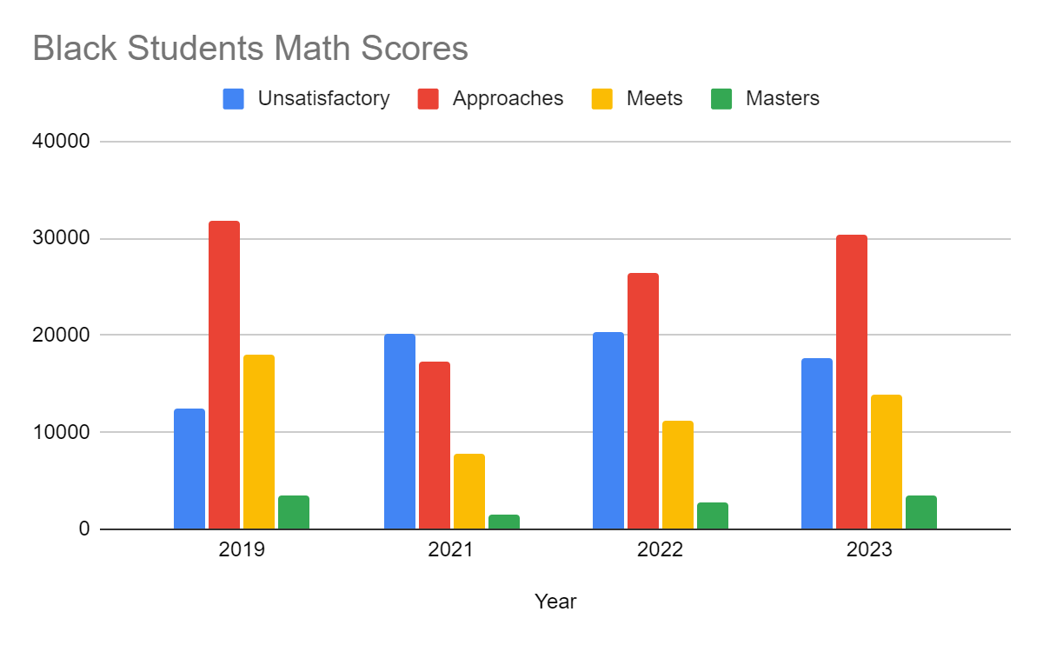

The widest academic achievement gap was observed among black students, constituting approximately 12% of the total student population. Across the four-year period, fewer than 10% of the 67,640 black students demonstrated proficiency in mathematics to be classified as students who had mastered the subject. The pandemic appears to have exacerbated the math gap, with only 18.31% of students receiving unsatisfactory results that did not meet grade level requirements in 2019. This percentage increased to about 41.44% in 2021. Despite marginal improvements, black students consistently had the highest number of students with subpar grades over all four years.

The STAAR test results reveal disparities in learning outcomes in mathematics among various ethnic groups. Approximately 50% of test takers both pre and post-pandemic were of Hispanic origin. Despite constituting about half of the total student population, less than 10% of cohorts were able to master the concepts taught in mathematics. Prior to the pandemic, 13.04% of students had unsatisfactory performance, and post-pandemic results indicate a spike in these numbers.

Asian students comprised less than 10% of the total test takers in mathematics.They consistently had the highest percentage of students who mastered math across all four years, outperforming all other racial groups. Similar to all other racial groups, Asians also experienced learning losses, as reflected in their STAAR test results. However, they were able to recover and surpass pandemic levels faster than other ethnic groups.

The findings indicate that approximately 45% of white students consistently met grade level expectations throughout all four years. Similar to Asian students, white student cohorts demonstrated the ability to rebound from academic setbacks over time. Although there was a decline in 2021, there was an improvement in the percentage of students mastering mathematics in both 2022 and 2023. The performance of white students in meeting grade level requirements appeared more variable over time. These results have implications for public policy considerations.

Based on the bar graphs, the subjects that students seemed to have struggled with the most were in Math and Social Studies. From this we decided to perform t-tests for “unsatisfactory” scores in Math and Social Studies with the Hispanic students. The reason why we selected Hispanic students for our analysis was because they had the highest amount of students that took the STAAR exams.

**Table 1.1**

*STAAR Unsatisfactory Result Statistics for Social Studies Testing*

| Year | Race | Mean | Tstat | P value |
| --- | --- | --- | --- | --- |
| 2019 | Hispanic | 42.177 |  |  |
|  | White | 2.195 | 39.189 | 2.17E-249 |
|  | Black | 18.325 | 19.665 | 4.17E-81 |
|  | Asian | 2.695 | 38.555 | 4.59E-244 |
| 2021 | Hispanic | 47.686 |  |  |
|  | White | 15.381 | 26.923 | 6.35E-140 |
|  | Black | 20.315 | 20.726 | 3.12E-89 |
|  | Asian | 3.56 | 38.491 | 1.71E-244 |
| 2022 | Hispanic | 53.455 |  |  |
|  | White | 54.688 | -0.486 | 6.27E-14 |
|  | Black | 21.835 | 21.209 | 2.36E-93 |
|  | Asian | 3.749 | 38.756 | 1.41E-248 |
| 2023 | Hispanic | 50.504 |  |  |
|  | White | 15.053 | 27.916 | 1.69E-150 |
|  | Black | 22.177 | 18.869 | 5.45E-83 |
|  | Asian | 3.684 | 38.97 | 4.07E-252 |

**Table 1.2**

*STAAR Unsatisfactory Result Statistics for Math Testing*

| **Year** | **Race** | **Mean** | **Tstat** | **P value** |
| --- | --- | --- | --- | --- |
| 2019 | Hispanic | 20.465 |  |  |
|  | White | 6.573 | 22.912 | 6.28E-105 |
|  | Black | 11.318 | 12.71 | 4.51E-36 |
|  | Asian | 0.976 | 33.92 | 7.89E-198 |
| 2021 | Hispanic | 38.816 |  |  |
|  | White | 11.662 | 25.388 | 4.07E-125 |
|  | Black | 18.686 | 16.694 | 8.74E-60 |
|  | Asian | 2.326 | 35.432 | 2.24E-212 |
| 2022 | Hispanic | 34.278 |  |  |
|  | White | 10.34 | 24.954 | 2.17E-122 |
|  | Black | 17.607 | 14.828 | 4.32E-48 |
|  | Asian | 1.978 | 35.451 | 8.39E-214 |
| 2023 | Hispanic | 29.908 |  |  |
|  | White | 8.296 | 24.571 | 1.89E-119 |
|  | Black | 17.607 | 1.486 | 1.37E-14 |
|  | Asian | 1.672 | 33.943 | 3.23E-200 |

From these results, two conclusions can be drawn upon. The first being that the average number of students who failed the STAAR per school rose across races from 2019-2021. According to Dorn et al (2021) on average as a result of the pandemic, students fell behind 5 months as a result of the pandemic. These findings are further supported by Table 1 and 2 where the data was divided by race and each race experienced a similar increase in failing students for testing results. The Hispanic population was chosen as a control group as they have the highest amount of students for all testing situations. Therefore a T-Test with unknown variances was conducted to determine the significance of these findings. It is widely accepted that a T-Stat value of over 2 is statistically significant. For all T-Stat values found, only 2 were considered to be under this threshold or statistically insignificant. A possible explanation for these values could be a lower testing population for Blacks in 2023 in table 2 and Whites in 2022 in table 1. Overall, these results indicate that these results are not only for the most part significant but also supports the thought that testing scores decreased majorly in social studies and math as a result of the pandemic. As compared to other subjects social studies, and math were easily the ones most affected by the lack of continuing education from the pandemic. These results are exemplified in the tables above and are supported by the literature review.

In terms of P-Values, a two tailed test was conducted, with the results displayed in the tables above for math and social studies. All P-Values were less than 0.01 by a wide margin and therefore considered significant. The increases from 2019 to 2021 in unsatisfactory testing, display how the average number of STAAR failing students is directly related to pandemic. Loss of school time, isolation, illness, online learning, are all among reasons as to why there was an increase to begin with. However the most directly affected subjects, social studies and math are to be considered more greatly compared to the other subjects. In some cases the average number of failing students jumped by double digits during this time period. Therefore it is our recommendation that policy makers focus on social studies and mathematical curriculum to make up for this loss in scores.

## Conclusion

Our results indicated that overall testing scores decreased as a result of the pandemic. Average failure rates increased across all schools, ethnicities and subjects. Two of the most prominent subjects that experienced the greatest drop offs in passing rates were social studies and math in STAAR testing. Using T-testing methodology to further identify the significance of these findings found that most of these results were in fact significant. The drop off in STAAR test scores can be attributed to pandemic related occurrences. In order to address these a deeper understanding of the Texas education system is required.

In Texas, the education system is overseen by the Texas Education Agency (TEA). The state follows the Texas Essential Knowledge and Skills (TEKS) curriculum, which outlines the content and skills that students are expected to learn at each grade level. In 8th grade, students typically study a range of subjects, including mathematics, science, English language arts, social studies, and other elective courses. Texas may have various educational initiatives in place to improve student outcomes, teacher quality, and overall school performance. These initiatives can include professional development programs, curriculum updates, and special programs for certain student populations.

The analysis revealed that the pandemic had resulted in losses in academic achievement across all ethnic groups. The varied gap in learning is a proof of inequity among various ethnicities. The students of White and Asian- origin were only marginally affected but were able to rebound from the effects of the pandemic. The Hispanic and Black students however have been left behind. The findings can be corroborated with the results from NAEP.

The National Association of Academic Procurement (NAEP) published a report on the state of education across the country for mathematics, reading and science. As of 2022, the average test scores of Texas were less than the national average of 261. Overall, only the White and Asian ethnic groups scored above the national average. With respect to reading, only the white cohort’s performance declined from 2019 to 2022. The minority ethnicities showed no significant deviations from the national average in reading. There was a decline in the average scores of all students across states in the US from 2019 to 2022. Post-pandemic, learning losses were also reported in mathematics. The state of Texas saw a decrease in NAEP scores. All races saw a decrease in math test scores after the pandemic.

Simon (2021) discussed how the pandemic exacerbated the racial education gap in the country. Reimer attributed the disparity to systemic racism and limited digital access. In addition to the socio-economic issues, the article also highlighted the imbalance in funding across various school districts. The article emphasizes on the need for addressing this issue as a civic problem requiring attention from policy makers. A study by edubuild stated that non-white districts got seven percent less funding than white districts in Texas. The article by Lopez (2023) raised concern over Texas students struggling with reading and math. The writer went on to reiterate the racial disparity in Texas. It also touched upon the various initiatives taken by the Texas Legislature. Richman’s (2023) article also raised concerns over the STAAR test scores and racial gap that continued to persist.

The TEA (Texas Education Agency) had put forth a strategic plan to address issues in reading and mathematics. The action items for the goal emphasized on scaling up Texas Reading Academies State-wide. The Texas Reading Academies' content was grounded in the Science of Teaching Reading (STR), with educators applying their knowledge of the STR across diverse teaching contexts to enhance reading outcomes for all learners. The program also included Reading fluency, comprehension amongst other skill sets. The academies offered three paths, teachers of general education and special education with an emphasis on English Language Arts, teachers of bilingual general education and special education with an emphasis on biliteracy, and administrators making up the third group. TEA plans to continue expansion of Math innovation zones with the goal to encourage blended learning initiatives. These include faculty-led and online instruction as well as assessment methods. It also aims to offer instant feedback to teachers on

While the initiatives have been taken to reverse the impact of the pandemic, it may not necessarily address the underlying issue. An in-depth policy evaluation of these education initiatives can help identify the weaknesses. The Education Development Center suggests revamping the curricula to make it more inclusive. Giving students a platform to redress grievances can also be beneficial. Reforming the way students are disciplined can also improve achievements. The EDC also suggests a restorative approach to encourage equity.

## Works Cited

Bailey, D. H., Duncan, G. J., Murnane, R. J., & Au Yeung, N. (2021). Achievement gaps in the

wake of COVID-19. *Educational Researcher*, *50*(5), 266–275.https://doi.org/10.3102

/0013189x211011237

Bozkurt, A., Karakaya, K., Turk, M., Karakaya, Ö., & Castellanos-Reyes, D. (2022). The Impact of COVID-19 on Education: A Meta-Narrative Review. *TechTrends*, *66*(5), 883–896. https://doi.org/10.1007/s11528-022-00759-0

Burkholder, E., & Salehi, S. (2023). Effects of the COVID-19 pandemic on academic preparation and performance: a complex picture of equity. *Frontiers in Education*, *8*. https://doi.org/10.3389/feduc.2023.1126441

Di Pietro, G. (2023). The impact of covid-19 on student achievement: Evidence from a recent

meta-analysis. *Educational Research Review*, *39*.https://doi.org/10.1016/j.edurev.

2023.100530

Dorn, E., Hancock, B., Sarakatsannis, J., & Viruleg, E. (2021, July). *Covid-19 and education:*

*The lingering effects of unfinished learning*. Omeka RSS.https://is101fall2021.web.i

llinois.edu/items/show/468

EDC.(2020,September 2).<https://www.edc.org/3-ways-schools-can-support-racial-e>

quitye-and-overview/2021-2025-tea-strategic-plan.pdf

Kuhfeld, M., Soland, J., Lewis, K., & Morton, E. (2022, March 3). *The pandemic has had devastating impacts on learning. What will it take to help students catch up?* Brookings; Brookings.<https://www.brookings.edu/articles/the-pandemic-has-had-devastating-impacts-on-learning-what-will-it-take-to-help-students-catch-up/>

Lopez, B. (2023, August 16). Despite post-pandemic improvements, STAAR scores show Texas students are still struggling with math and reading. The Texas Tribune. https://www.texastribune.org/2023/08/16/texas-staar-scores-math-reading/

Rajwani-Dharsi, N. (2023, March 27). *Texas 8th graders are falling behind* . Axios Dallas.

https://www.axios.com/local/dallas/2023/03/27/texas-8th-graders-behind

Richman, T. (2023, August 17). STAAR results: Texas Students’ Reading Performance Steady,

math-sees-growth.DallasNews.<https://www.dallasnews.com/news/education/2023/08/16/s>

taar-results-texas-students-reading-scores-steady-math-sees-growth/

Sacerdote, B. (2012). When the Saints Go Marching Out: Long-term outcomes for student

evacuees from Hurricanes Katrina and rita. *American Economic Journal: Applied Economics*, *4*(1), 109–135. https://doi.org/10.1257/app.4.1.109

Simon, C. (2021, July 19). How covid taught America about inequity in Education.

HarvardGazette.<https://news.harvard.edu/gazette/story/2021/07/how-covid-taught-america-about-inequity-in-education/>

Tea strategic plan - welcome to Texas Education Agency. (n.d.).<https://tea.texas.gov/>

about-tea/welcom3 ways schools can support racial equity.